**RECIPE RECOGNITION WITH DEEP LEARNING**

A UG Phase- II Project

submitted by

MUPPALA KEERTHANA 18UK1A0534

BOURISHETTY SWETHA 18UK1A0556

KALERU NARESH 18UK1A0538

BHUKYA SANTOSH 18UK1A0507

**ABSTRACT**

Food is an essential component of our individual and social life. Eating habits have a direct impact on our health and wellbeing, while ingredients, flavour and cooking recipes shape specific cuisines that are part of our personal and collective cultural identities. But there are also interesting applications of automatic food recognition to self-service restaurants and dining halls. For instance, accurate detection and segmentation of the different food items in a food tray can be used for monitoring food intake and nutritional information, and automatic billing to avoid the cashier bottleneck in self-service restaurants. This work deals with the problem of automated recognition of a photographed cooking dish and the subsequent output of the appropriate recipe. In this project, we focus on applications of automatic food recognition and identify the recipe in food by using convolutional neural networks. And this model will classify images into food categories and to output a matching recipe.

**1.INTRODUCTION**

**1.1 OVERVIEW:**

Food is an essential component of our individual and social life. Eating habits have a direct impact on our health and wellbeing, while ingredients, flavour and cooking recipes shape specific cuisines that are part of our personal and collective cultural identities. But there are also interesting applications of automatic food recognition to self-service restaurants and dining halls. For instance, accurate detection and segmentation of the different food items in a food tray can be used for monitoring food intake and nutritional information, and automatic billing to avoid the cashier bottleneck in self-service restaurants. This work deals with the problem of automated recognition of a photographed cooking dish and the subsequent output of the appropriate recipe. In this project, we focus on applications of automatic food recognition and identify the recipe in food by using convolutional neural networks. And this model will classify images into food categories and to output a matching recipe.

**1.2 OBJECTIVE OF PROJECT:**

By the end of this project, you will:

• know fundamental concepts and techniques of the Artificial Neural Network and Convolution Neural Networks

• Gain a broad understanding of image data.

• Work with Sequential type of modelling

• Work with Keras and TensorFlow capabilities

• Work with image processing techniques

• know how to build a web application using the Flask framework.

**1.3 PURPOSE:**

By Using the Recipe Recognition with Deep Learning:

• We know the concepts and can work on Deep Learning Architecture.  
 • Applications of automatic food recognition includes self-service restaurants and dining halls.

• Accurate detection and segmentation of the different food items in a food tray can be used for monitoring food intake and nutritional information, and automatic billing in restaurants.

**2. PROBLEM STATEMENT:**

• Our project deals with the problem of automated recognition of a photographed cooking dish and the subsequent output of the appropriate recipe.

• In this project, we focus on applications of automatic food recognition and identify the recipe in food by using convolutional neural networks.

• Our Deep Learning model will classify images into food categories and to output a matching recipe.

**3.LITERATURE SURVEY:**

**3.1 EXISTING SYSTEM:**

• The distinction between the difficulty of the chosen problem and previous supervised classification problems is that there are large overlaps in food dishes, as dishes of different categories.

• combination of object recognition using Convolutional Neural Networks (short CNN) over the input record of images. • Implementations of techniques and concepts of Convolutional Neural Networks helps to find the recipe more likely.

**3.2 PROPOSED SYSYEM:**

We are creating a web application where the user selects the image which is to be classified. The image is fed into the model that is trained and the output will be displayed on the webpage.

Our Convolutional Neural Network model is for accurate recognition of a photographed cooking dish and the subsequent output of the appropriate recipe.

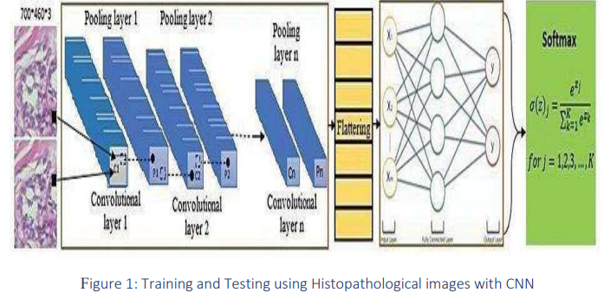

These filters scan the image by a sliding window on the image, while learning the recurrent patterns which arise in any area of the image. The interval between filters is known as the stride. The convolution is extended to overlapping windows if the stride hyper parameter is smaller than the filter dimension. Convolutional layers bring out the features of images with precise positions. If the positions change, even a small amount for any reason, the feature maps will be different.

To overcome this problem, the down sampling process must be done at the output of every convolutional layer. With convolutional layers, down sampling can be done by changing the convolution’s phase across the image.

**DEEP LEARNING:**

Deep learning neural networks, or artificial neural networks, attempts to mimic the human brain through a combination of data inputs, weights, and bias. These elements work together to accurately recognize, classify, and describe objects within the data.

Deep neural networks consist of multiple layers of interconnected nodes, each building upon the previous layer to refine and optimize the prediction or categorization. This progression of computations through the network is called forward propagation.The input and output layers of a deep neural network are called visible layers. The input layer is where the deep learning model ingests the data for processing, and the output layer is where the final prediction or classification is made.

Another process called backpropagation uses algorithms, like gradient descent, to calculate errors in predictions and then adjusts the weights and biases of the function by moving backwards through the layers in an effort to train the model. Together, forward propagation and backpropagation allow a neural network to make predictions and correct for any errors accordingly. Over time, the algorithm becomes gradually more accurate.

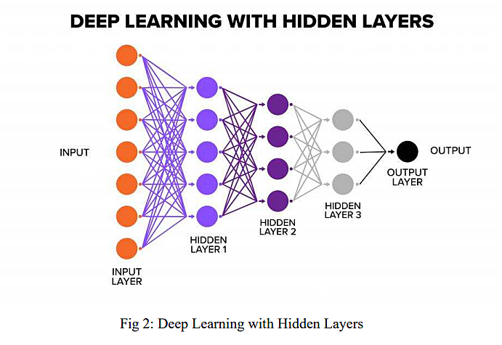

**CONVOLUTIONAL NEURAL NETWORKS:**

A convolutional neural network is a specific kind of neural network with multiple layers. It processes data that has a grid-like arrangement then extracts important features.

Convolutional neural networks are based on neuroscience findings. They are made of layers of artificial neurons called nodes. These nodes are functions that calculate the weighted sum of the inputs and return an activation map. This is the convolution part of the neural network.

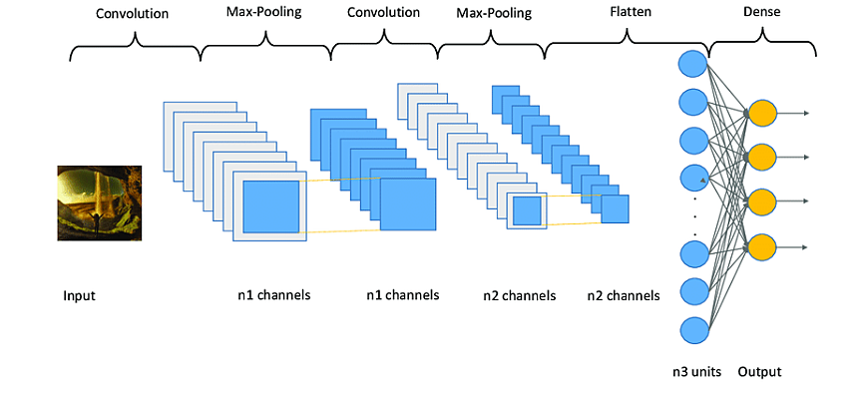

Each node in a layer is defined by its weight values. When you give a layer some data, like an image, it takes the pixel values and picks out some of the visual features.

Usually with images, a CNN will initially find the edges of the picture. Then this slight definition of the image will get passed to the next layer. Then that layer will start detecting things like corners and colour groups. Then that image definition will get passed to the next layer and the cycle continues until a prediction is made.

**4.THEORITICAL ANALYSIS:**

**4.1 BLOCK DIAGRAM:**

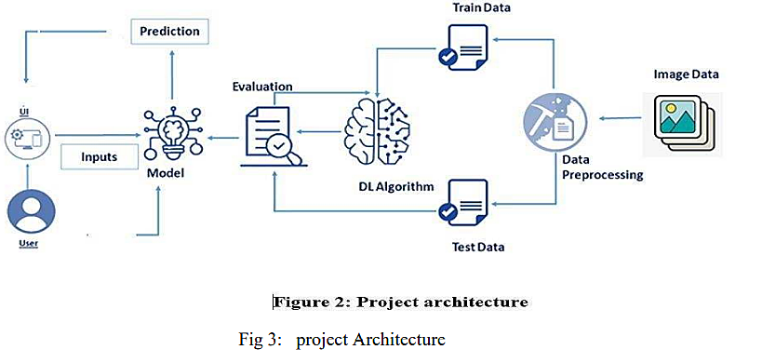

**4.2 USE CASE DIAGRAM:**

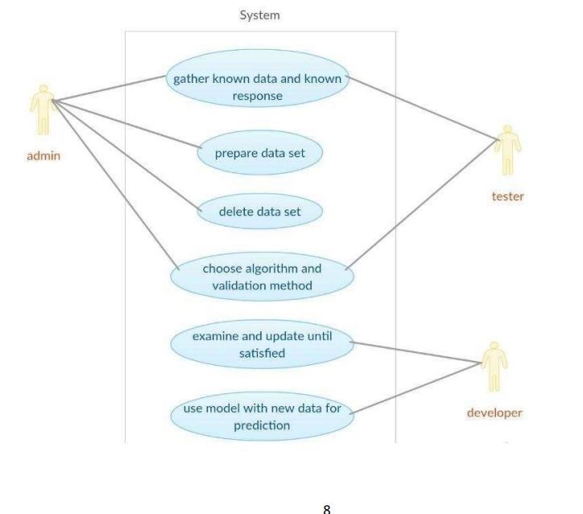

Fig 4. Use Case diagram for model building

**4.3 SOFTWARE SPECIFICATIONS:**

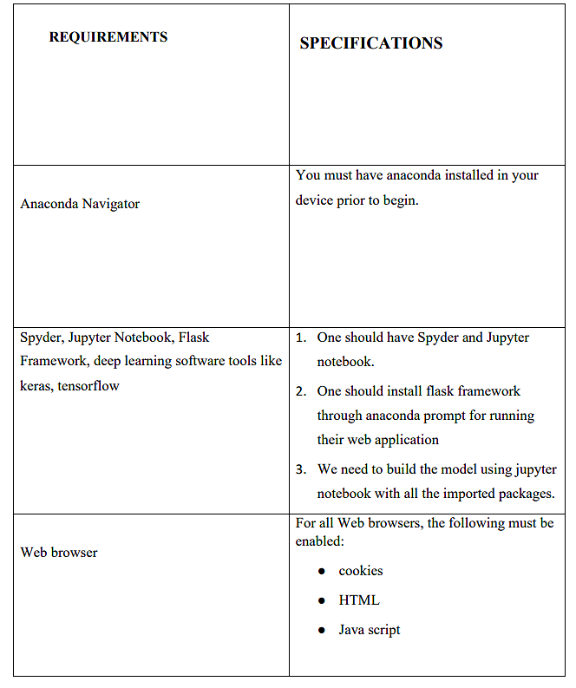

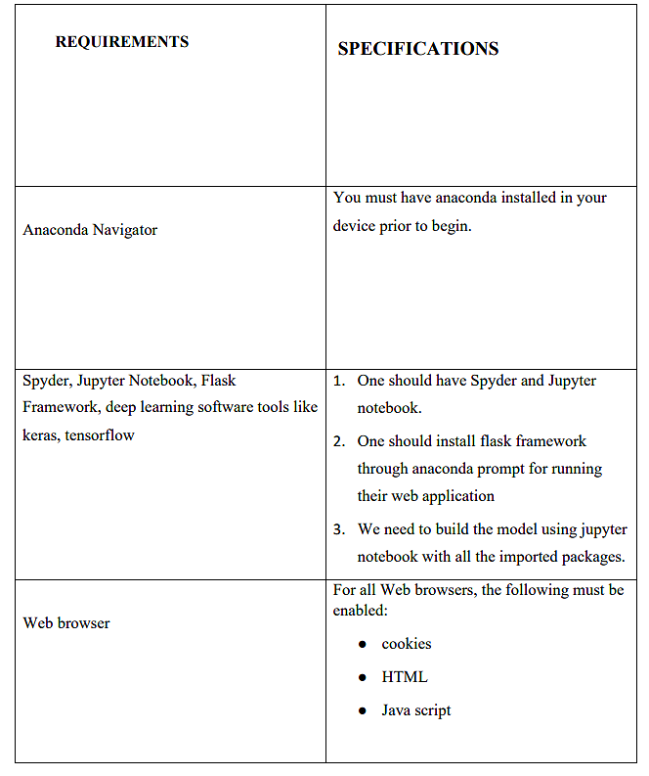

**4.4 HARDWARE SPECIFICATIONS:**

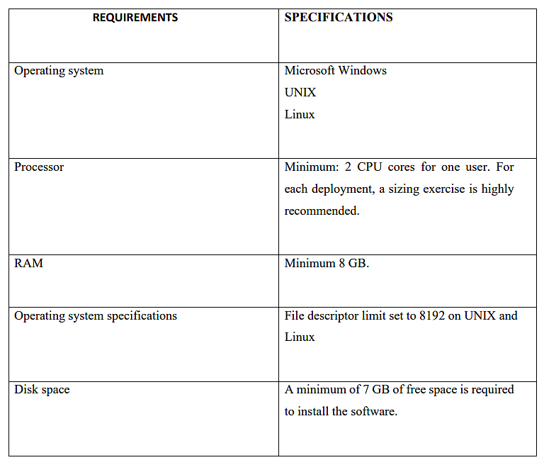

**5.EXPERIMENTAL ANALYSIS:**

In this project, we focus on applications of automatic food recognition and identify the recipe in food by using convolutional neural networks. And this model will classify images into food categories and to output a matching recipe.

• User interacts with the UI (User Interface) to upload the image as input

• Uploaded image is analysed by the model which is integrated

• Once model analyses the uploaded image, the model predicts the food item and the recipe is showcased on the UI.

**5.1 DATA COLLECTION:**

ML or DL depends heavily on data, without data, it is impossible for a machine to learn. It is the most crucial aspect that makes algorithm training possible. It is the actual data set used to train the model for performing various actions.

• Collect the dataset or create the dataset

**5.2 DATA PREPROCESSING:**

Image Pre-processing includes the following main tasks: The ImageDataGenerator accepts the original data, randomly transforms it, and returns only the new, transformed data.

• Import the ImageDataGenerator library

• Configure ImageDataGenerator class

• Apply ImageDataGenerator functionality to Trainset and Test set There are five main types of data augmentation techniques for image data; specifically:

• Image shifts via the width_shift_range and height_shift_range arguments.

• Image flips via the horizontal_flip and vertical_flip arguments.

• Image rotations via the rotation_range argument

• Image brightness via the brightness_range argument.

• Image zoom via the zoom_range argument.

**5.3 MODEL BUILDING:**

The neural network model is to be built by adding different network layers like convolution, pooling, flattening, dropout, and neural layers. In this milestone, we start building our model by:

• Import the model building Libraries

• Initializing the model

• Adding Input Layer

• Adding Hidden Layer

• Adding Output Layer

• Configure the Learning Process

• Training the model

• Save the Model

• Test the Model

**5.4 APPLICATION BUILDING:**

After the model is built, we will be integrating it into a web application so that users can interact with the model.

o Create an HTML file

o Build Python Code

**6. FLOW CHART:**

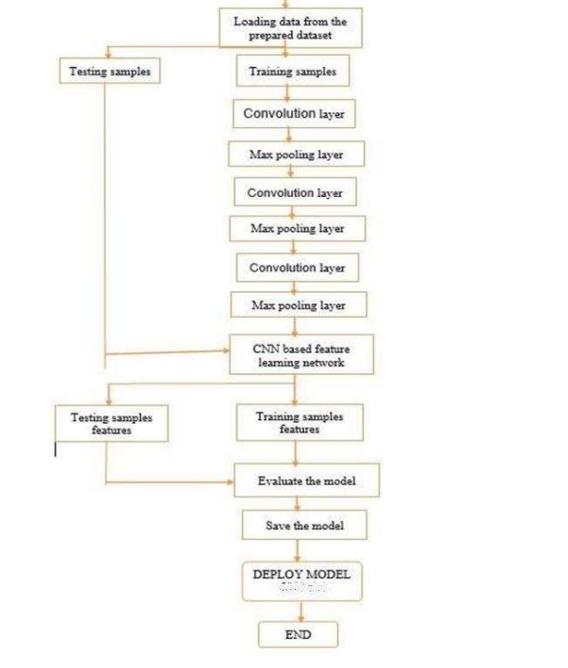

Fig 5: Flow Chart

**7.CODE SNIPPETS**

**7.1 MODEL CODE:**

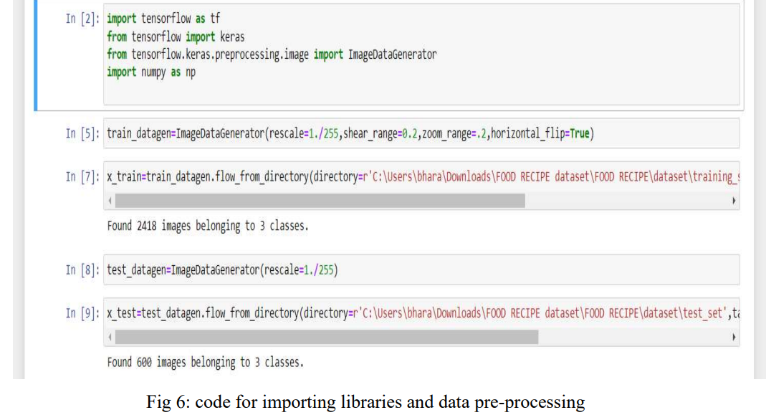

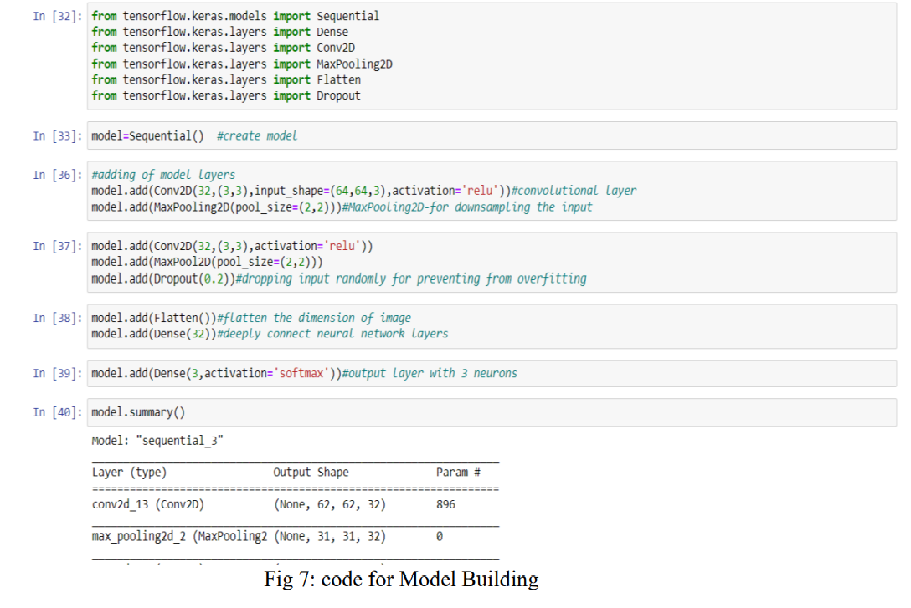

Fig 7: code for model building

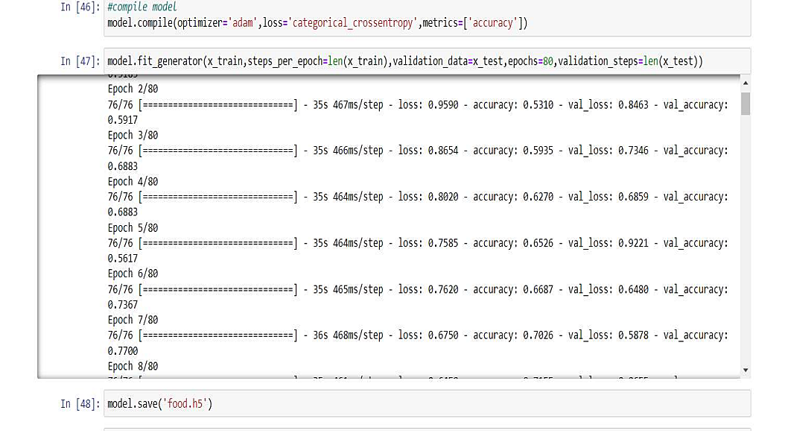

Fig 8: Code for Training the model

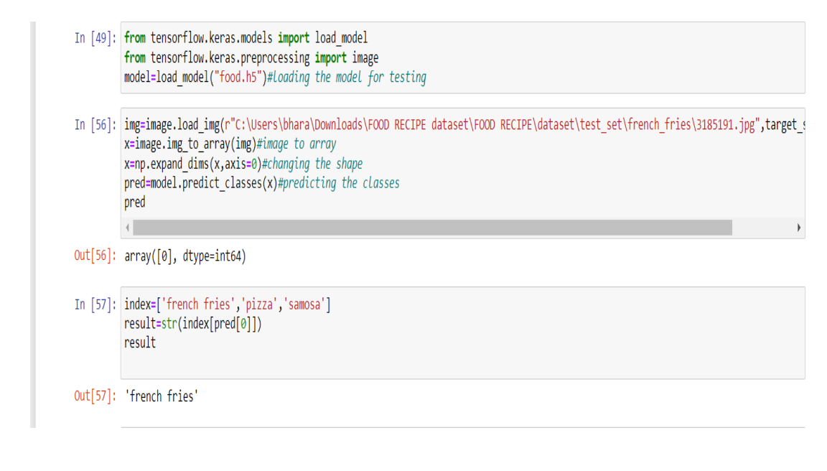

Fig 9: Code for testing for Model

**7.2 app.py CODE:**

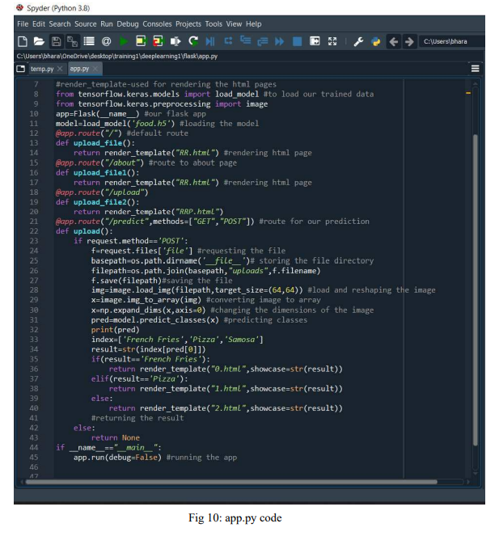

**7.3 HTML CODE:**

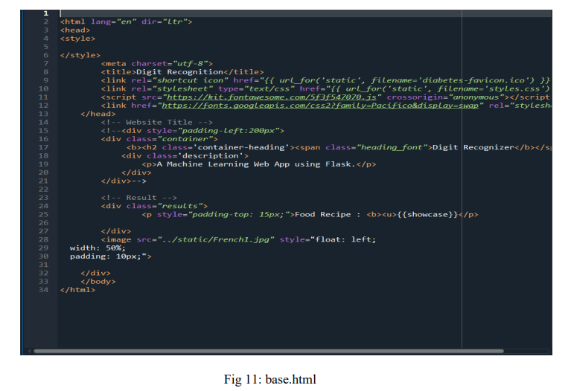

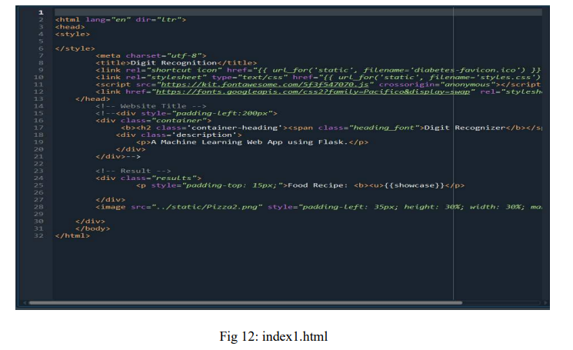

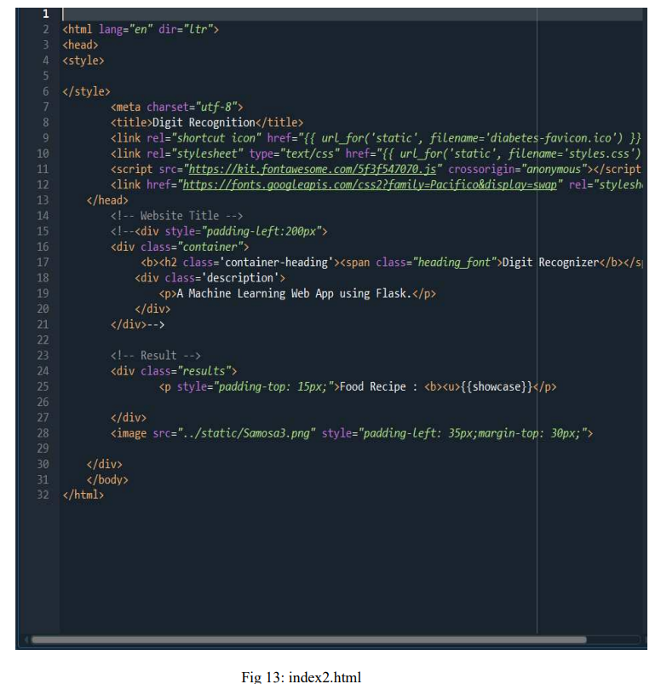

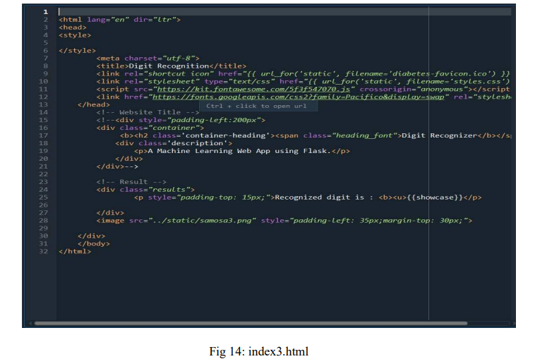

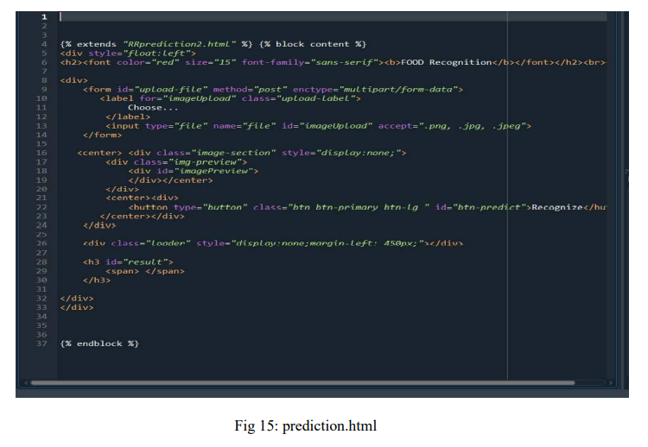

**8.CONCLUSION:**

The Following are the steps listed above are performed by our team, and herewith we attach snaps of our web page we attached.

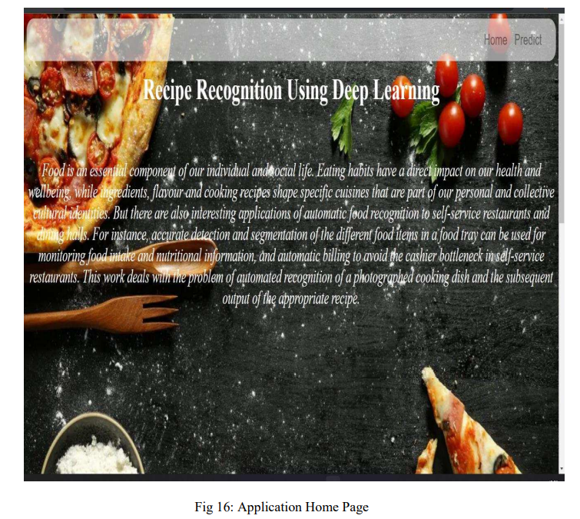

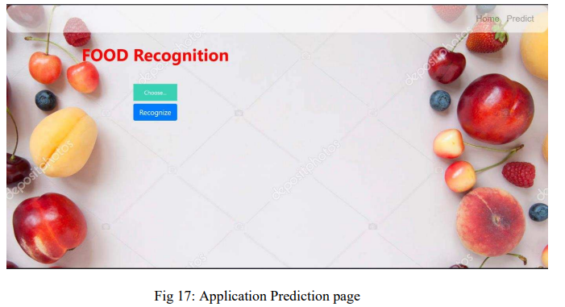

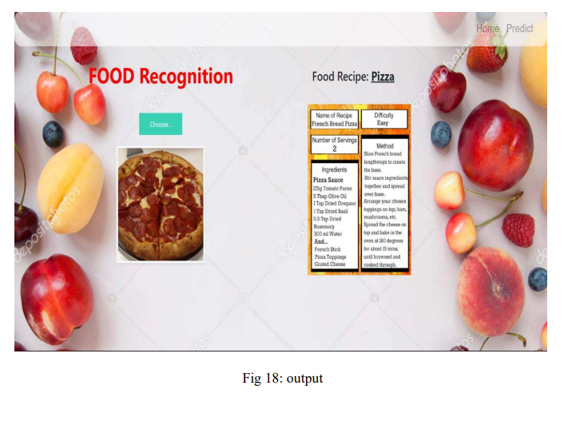

**9.APPLICATIONS**

• Applications of automatic food recognition to self-service restaurants and dining halls

. • For instance, accurate detection and segmentation of the different food items in a food tray can be used for monitoring food intake and nutritional information, and automatic billing to avoid the cashier bottleneck in self-service restaurants.

**10.ADVANTAGES**

• Food image classification is an emerging research field due to its increasing benefits in health and medical sectors.

• Automated food recognition tools will help in developing diet monitoring systems, calories estimation .

**11.DISADVANTAGES**

• Sometimes people may not be able to eat what they like the most.

• Taking too much out of our diet can be unhealthy.

**12.FUTURE SCOPE**

• in the future automated food recognition tools will help in developing diet monitoring systems, calories estimation.

• accurate detection and segmentation of the different food items in a food tray can be used for monitoring food intake and nutritional information, and automatic billing to avoid the cashier bottleneck in self-service restaurants.

**13.BIBLOGRAPHY**

ズ https://smartinternz.com/Student/guided_projects

ズ https://www.kaggle.com/paultimothymooney/breast-histopathology-image

**HELP FILE**

**PROJECT EXECUTION:**

STEP-1: Go to Start, search and launch **ANACONDA NAVIGATOR.**

STEP-2: After launching of **ANACONDA NAVIGATOR,** launch **JUPYTER NOTEBOOK**,open "food recepie" IPYNB file then run all the cells , a.h5 file will be generated.

STEP-3: Create a Folder named **FLASK** on the **DESKTOP**. Extract the food.h5 file into this Flask Folder.

STEP-4: Extract all the html files (index.html) and python file(app.py) into the FLASK Folder.

STEP-5: Then go back to **ANACONDA NAVIGATOR** and the launch the **SPYDER**

. STEP-6: After launching Spyder, give the path of FLASK FOLDER which you have created on the DESKTOP.

STEP-7: Open all the app.py and html files present in the Flask Folder.

STEP-8: After running of the app.py, open ANACONDA PROMPT and follow the below steps: cd file path--> click enter python app.py -->click enter (we could see running of files).

STEP-9: Then open BROWSER, at the URL area type "localhost:5000".

STEP-10: Home page of the project will be displayed.

STEP-11: In the home page of the project click on choose file, then select an image file from the dataset

. STEP-12: . Now click on the "click to predict" button below the uploaded file, the recipe of the uploaded food image is displayed on the screen.